Prompt engineering
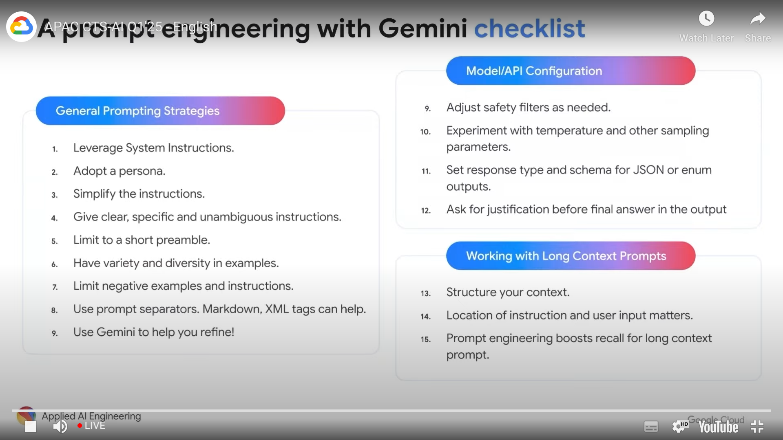

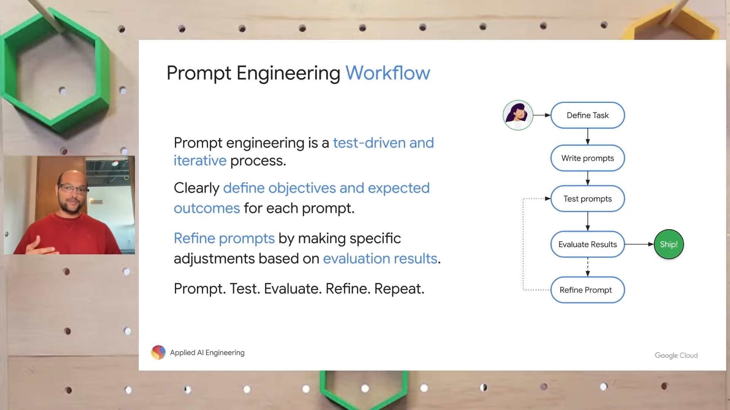
prompt engineering – workflow

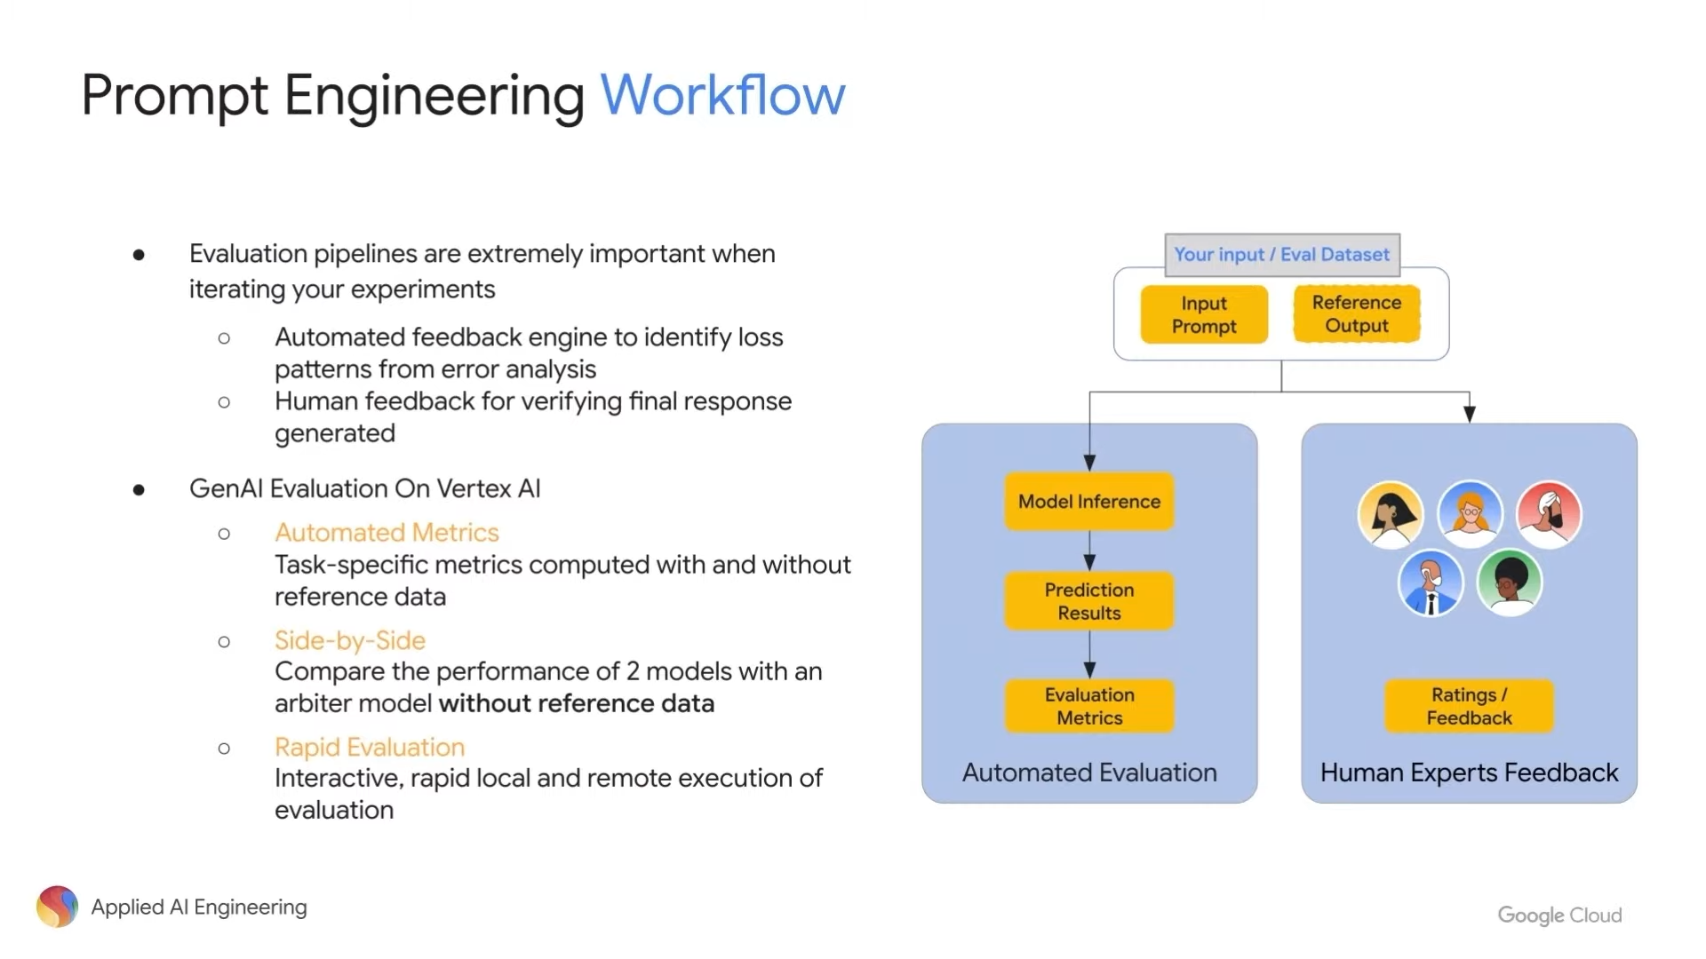
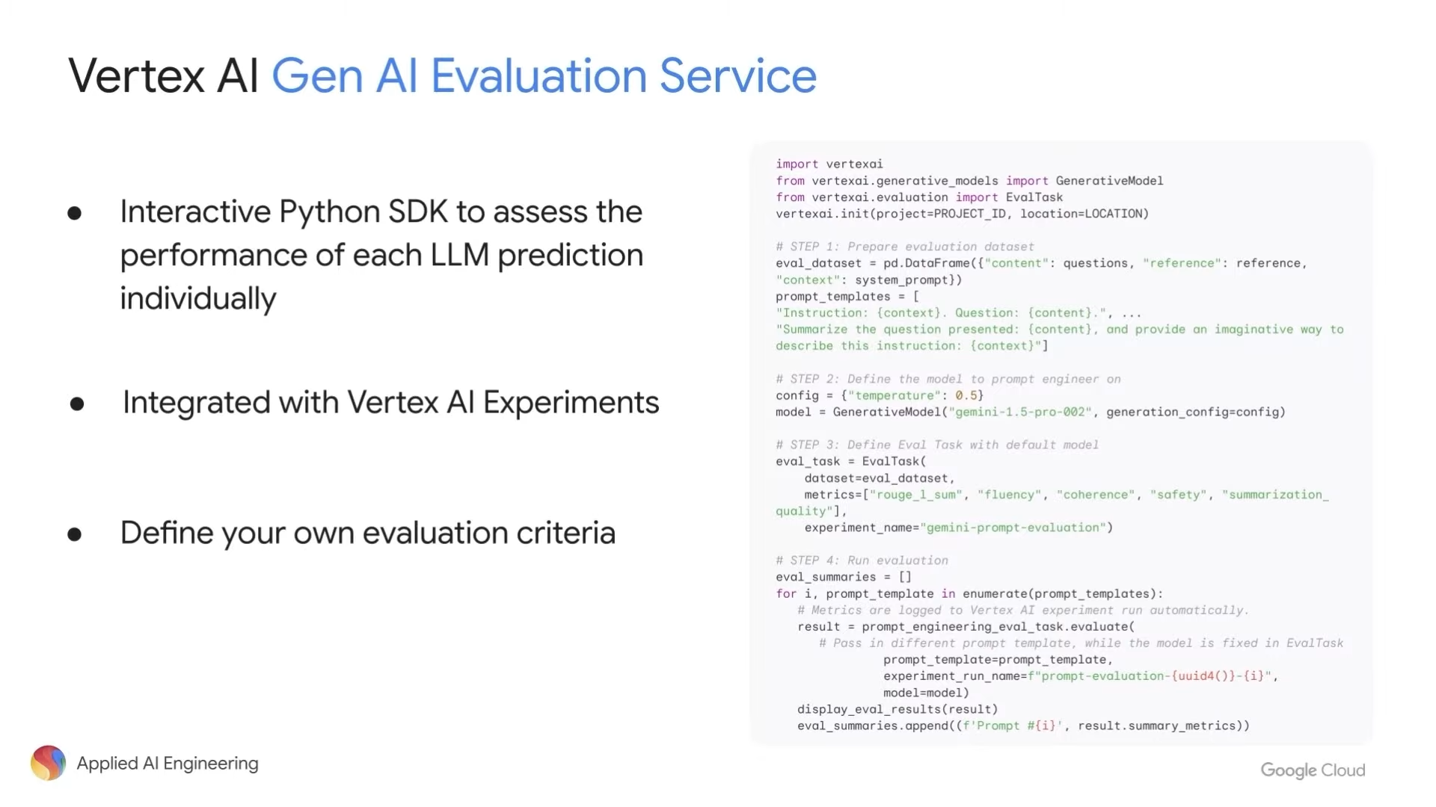
evaluation metrics
temperature and other sampling parameters:
temp < 1 – predication or code generation
temp > 1 – creative task

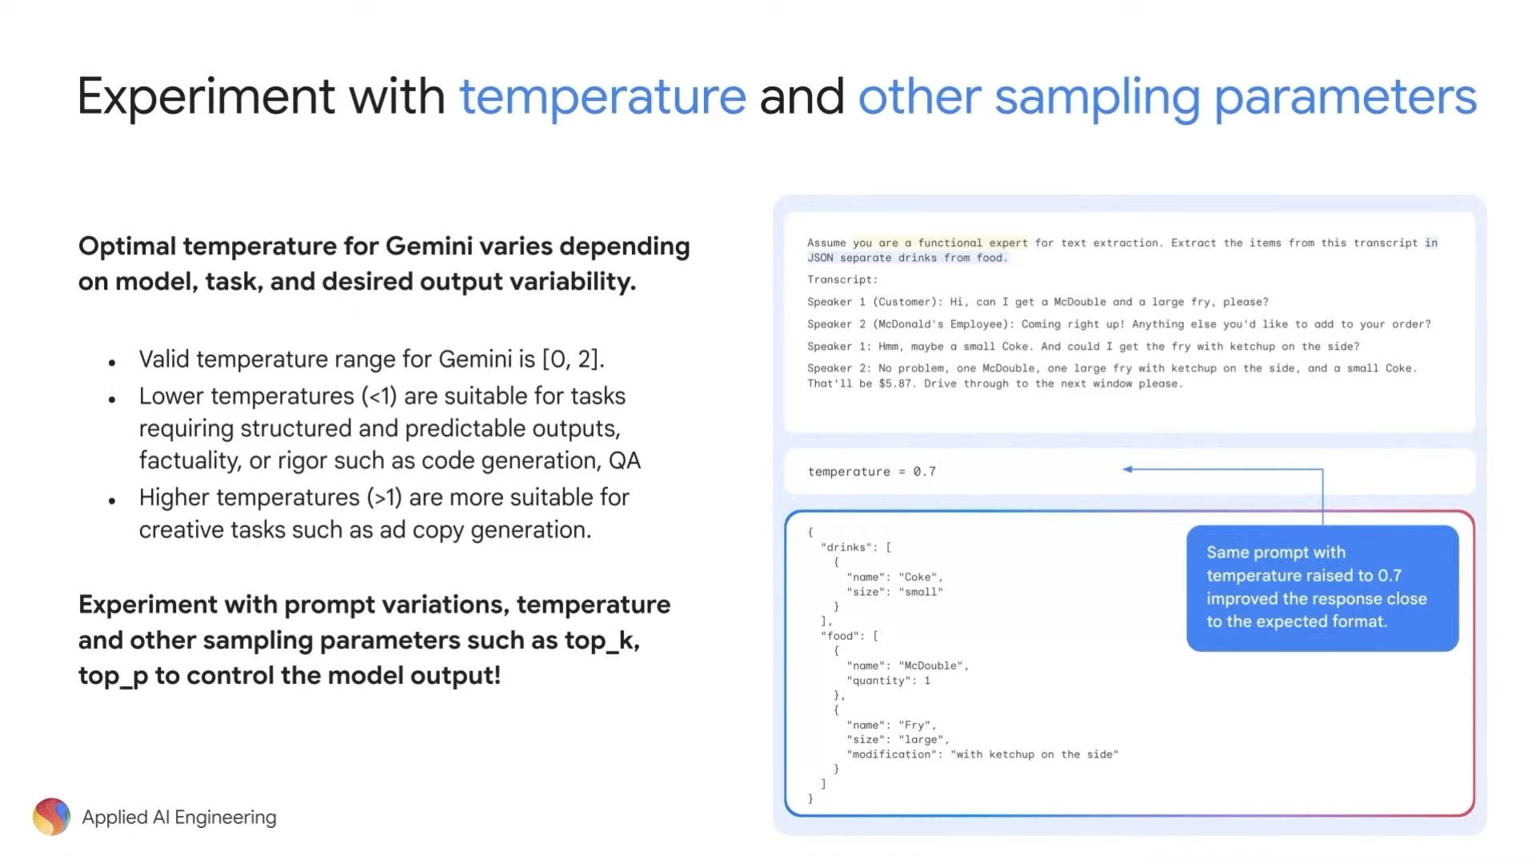
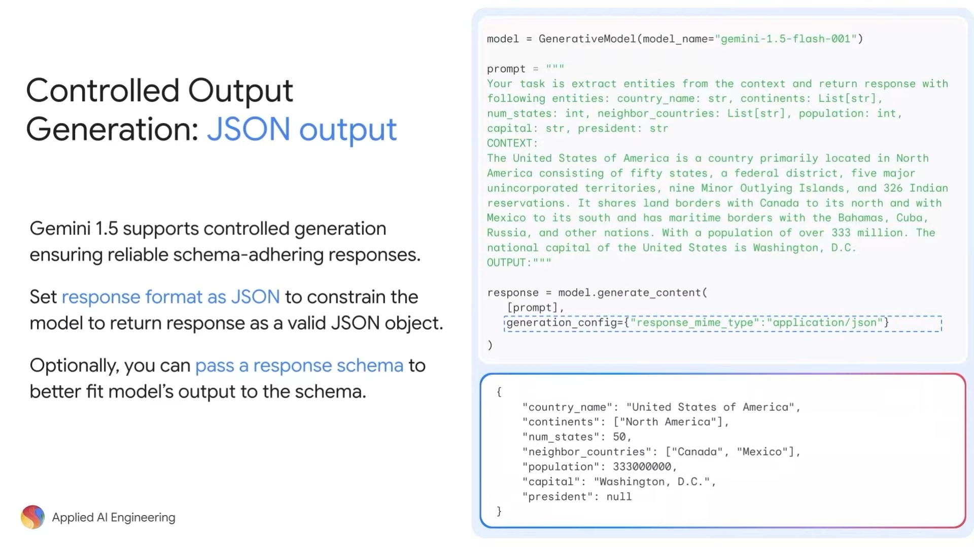
output generation – JSON output
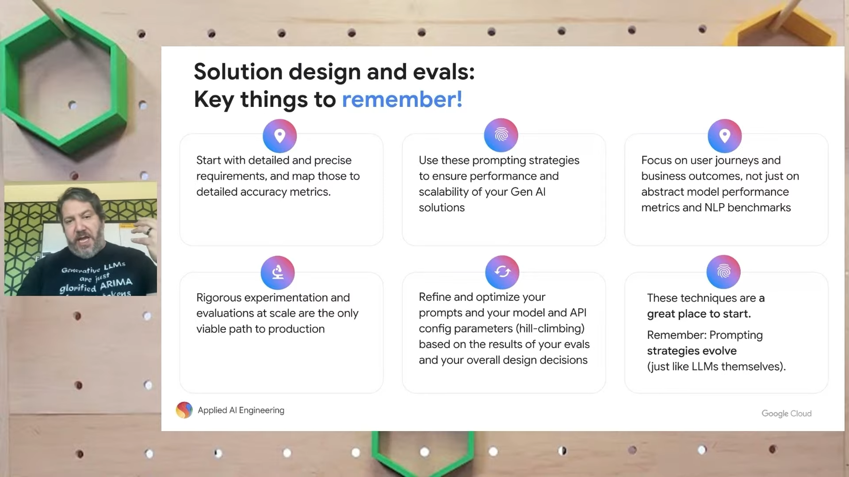
solution design and evals – key things!
Long context windows

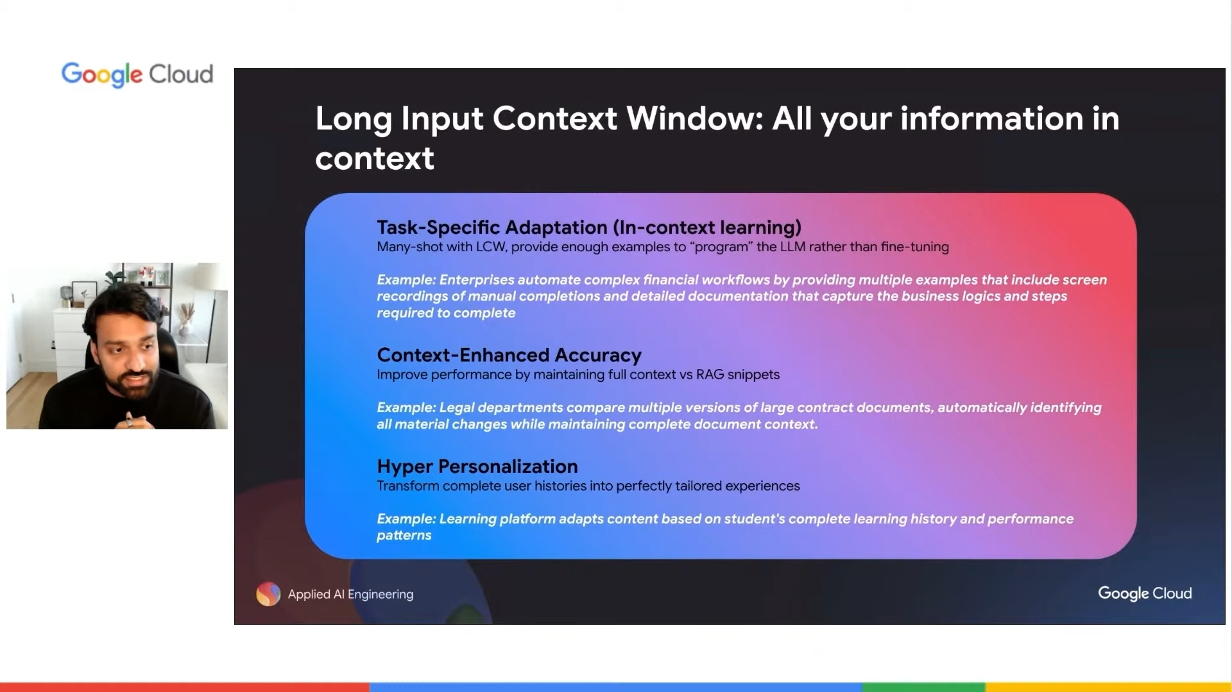
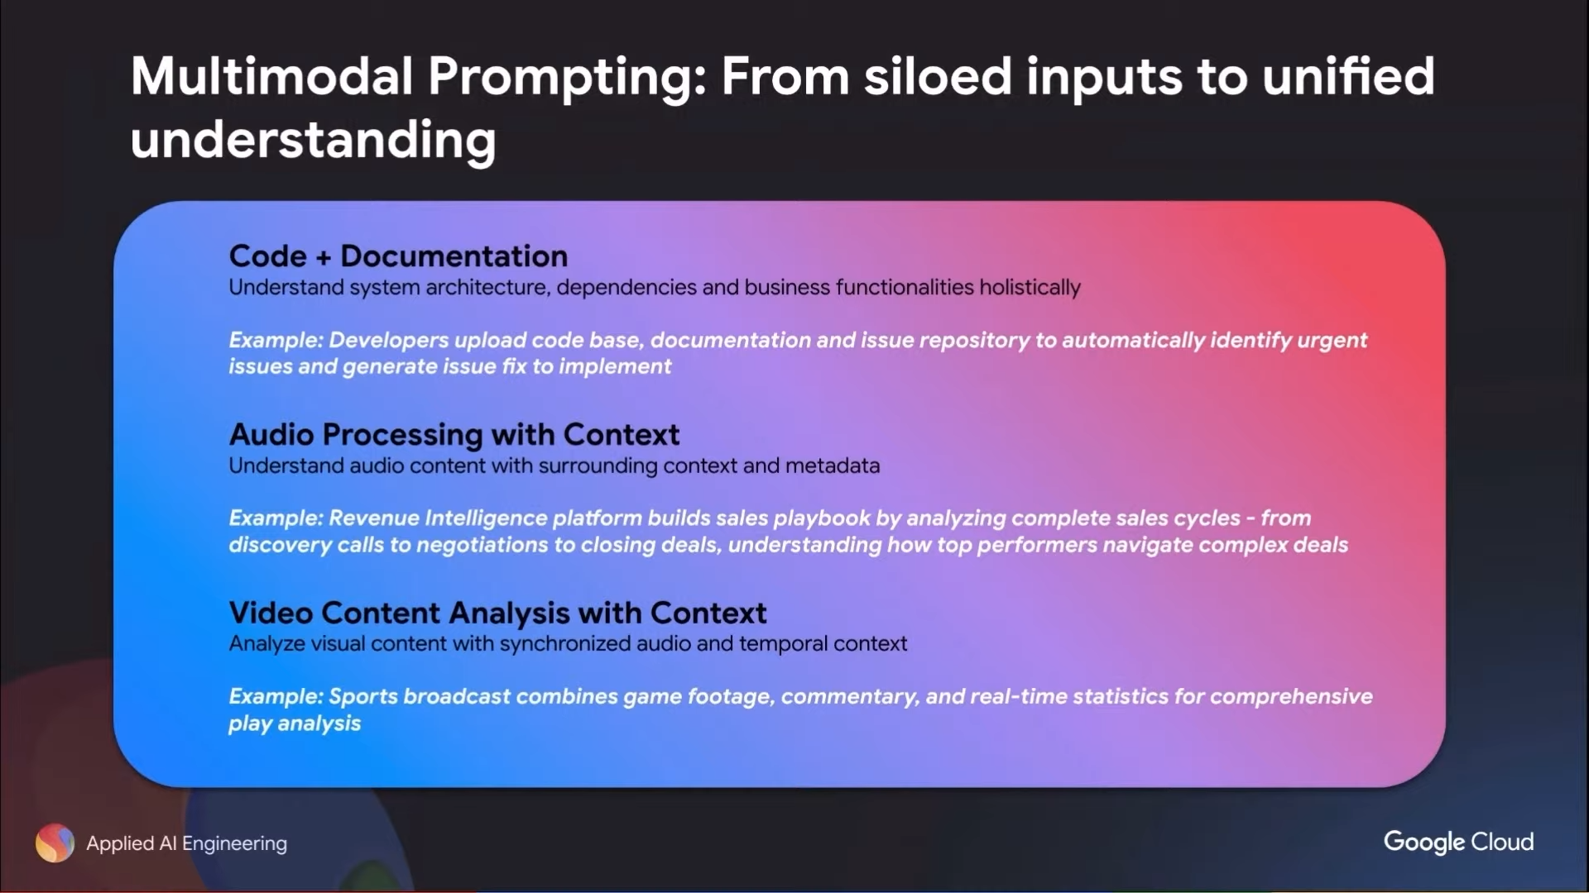
multimodal prompting -
multimodal prompting:

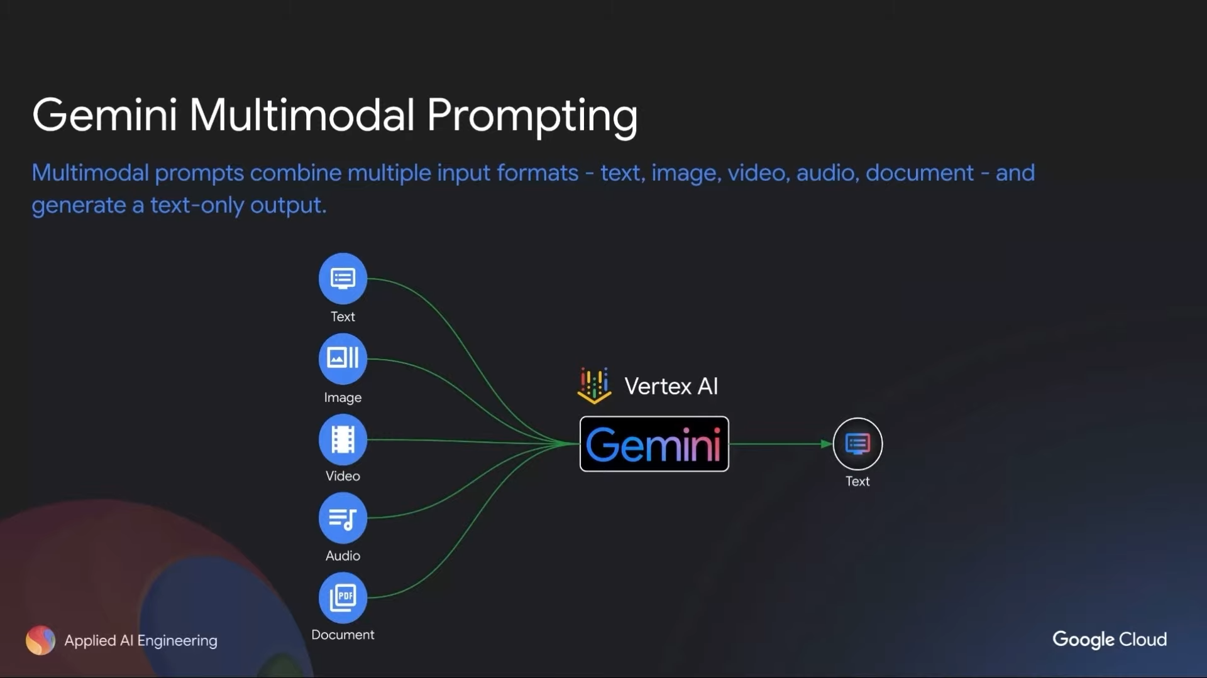

eg – code format for multimodal

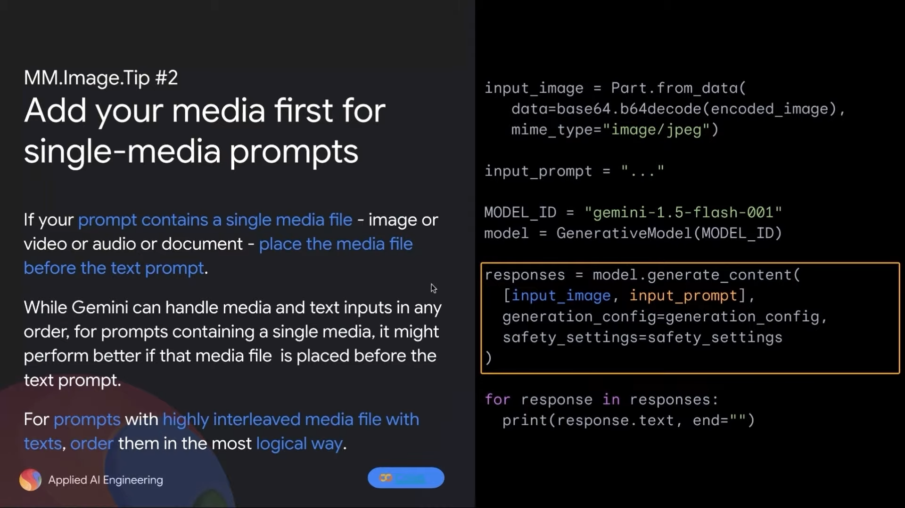
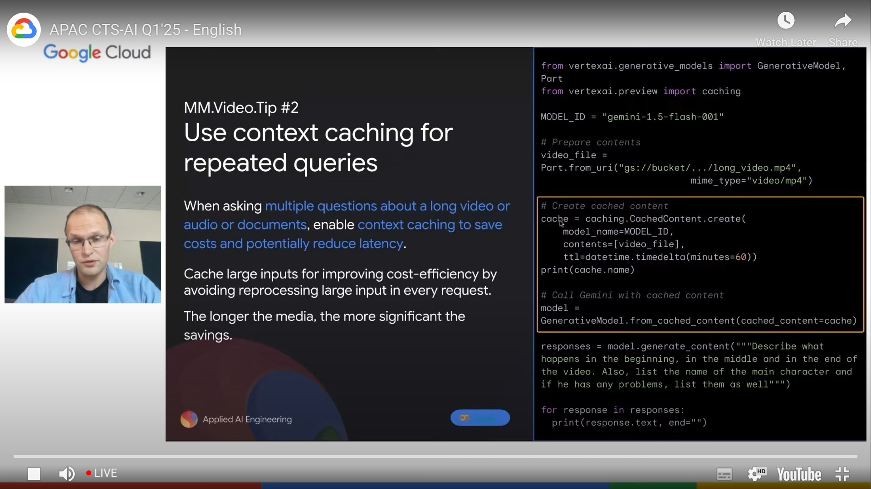
cache content – reduce the cost also reduces the latency

long context window prompting! link
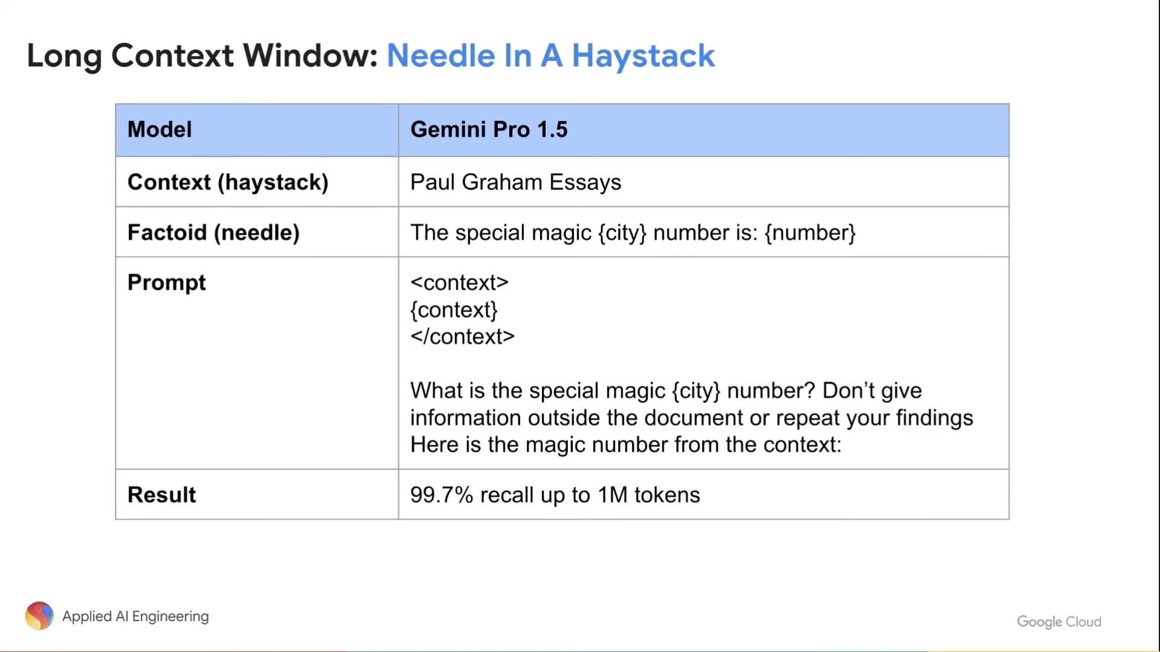
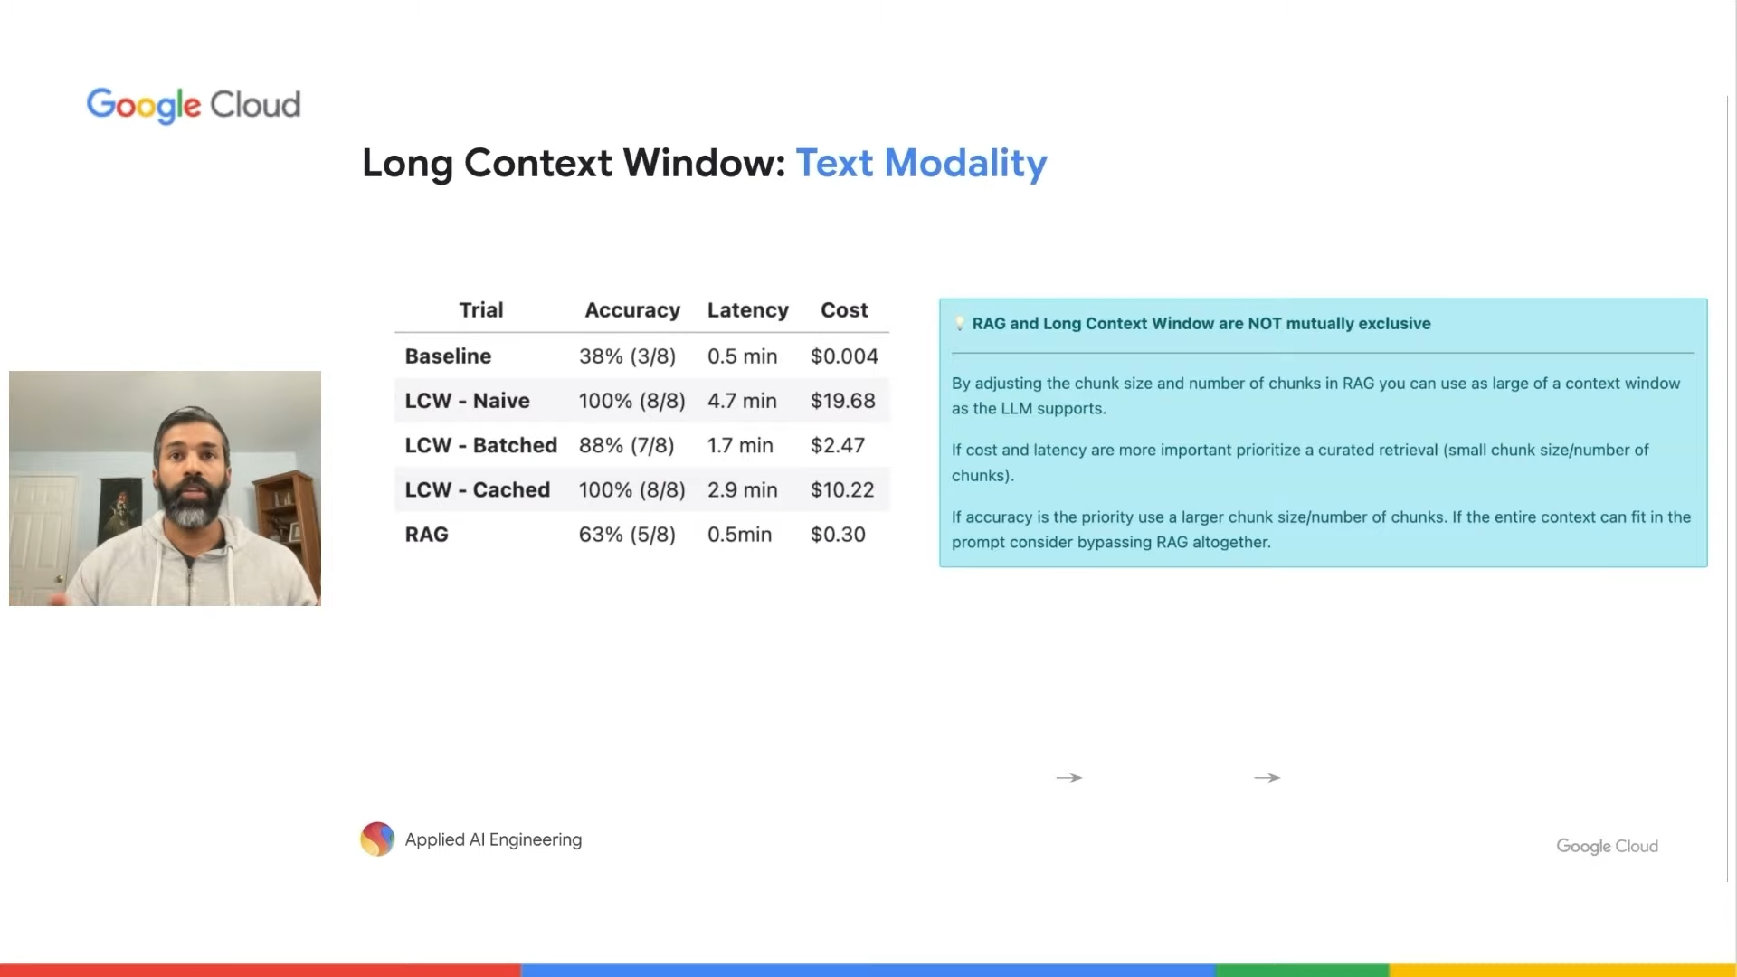
long context window – text modality
bached(single , multi needle) vs caching
lcw vs rag
conclusion:
beyond chatbots – the world of ai agents
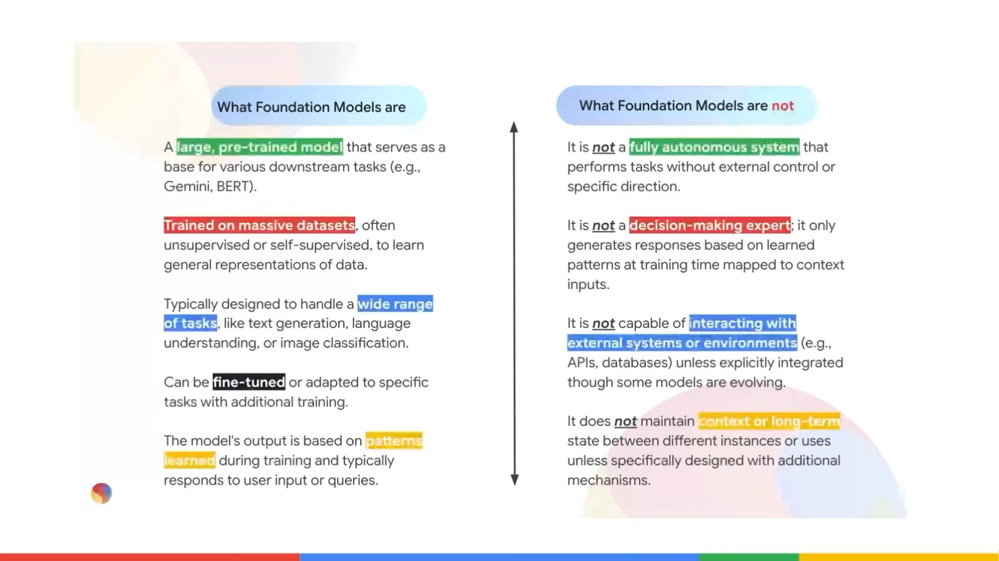
foundation vs not foundation model
what is an agent ? Ai agent ?

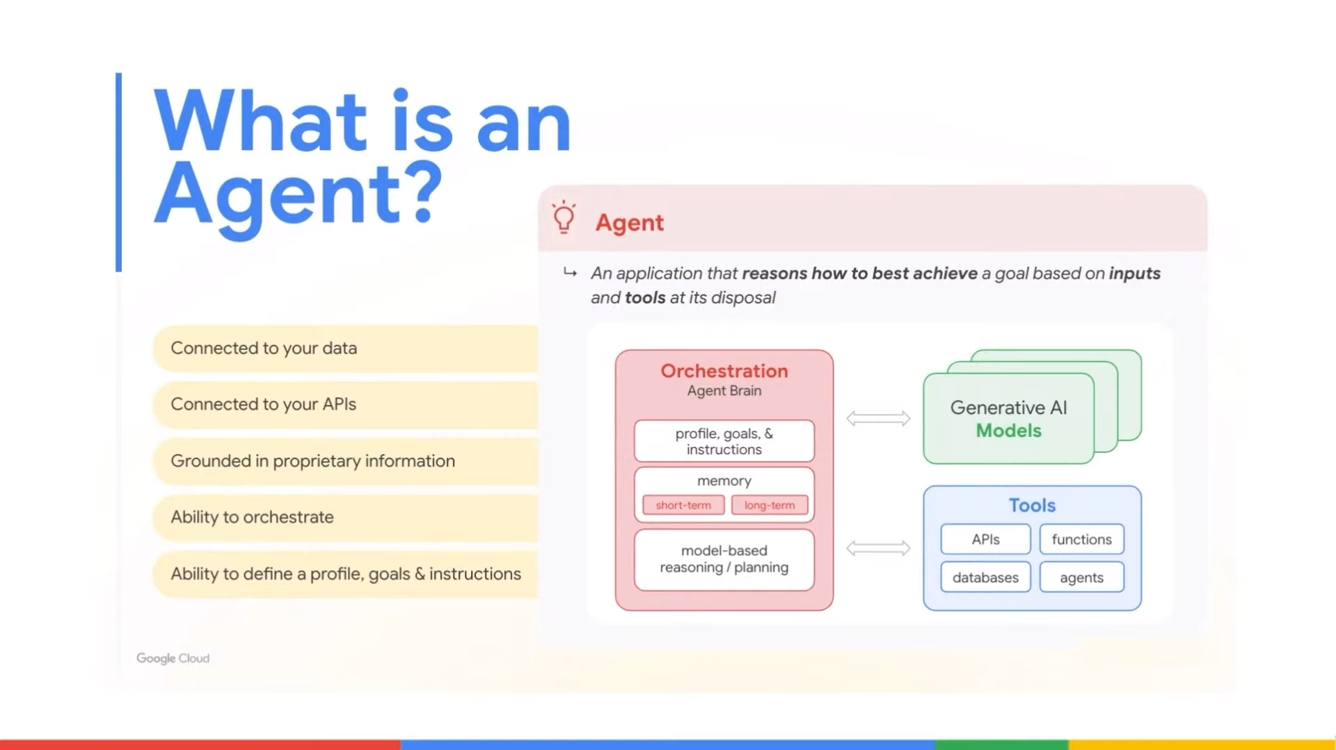
Chatbot was good but need reasoning – ai agent
1. connect data – rag
2. connect api
3. grounded in proprietary information
4. ………………
mutli agent concept!
Types
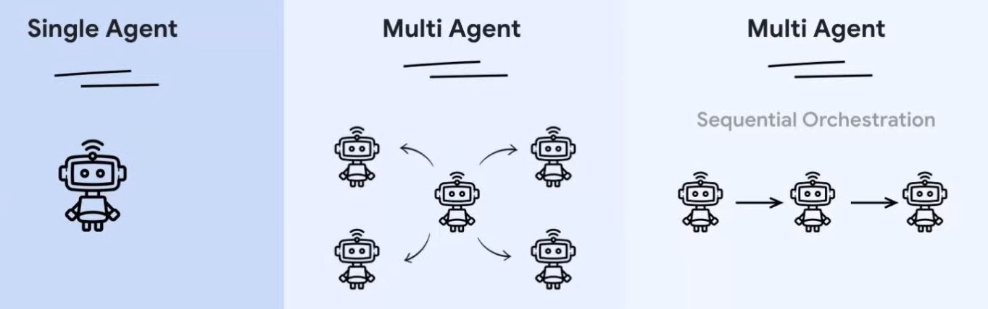
1. main agent to orchestrate
2. sequential orchestration

complexities:
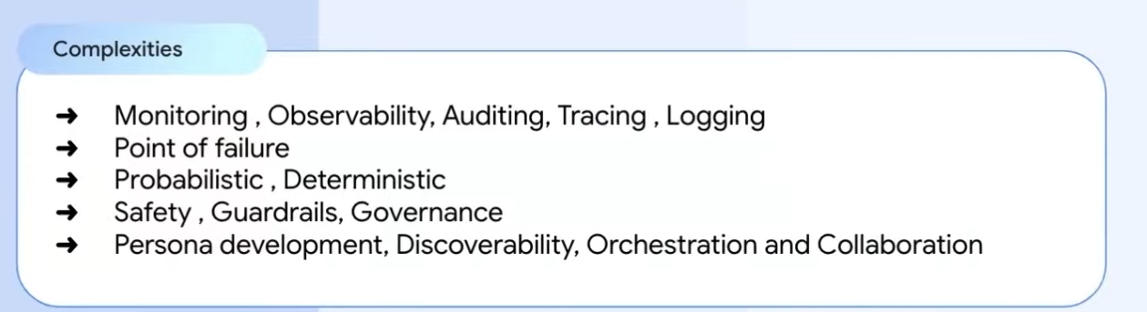

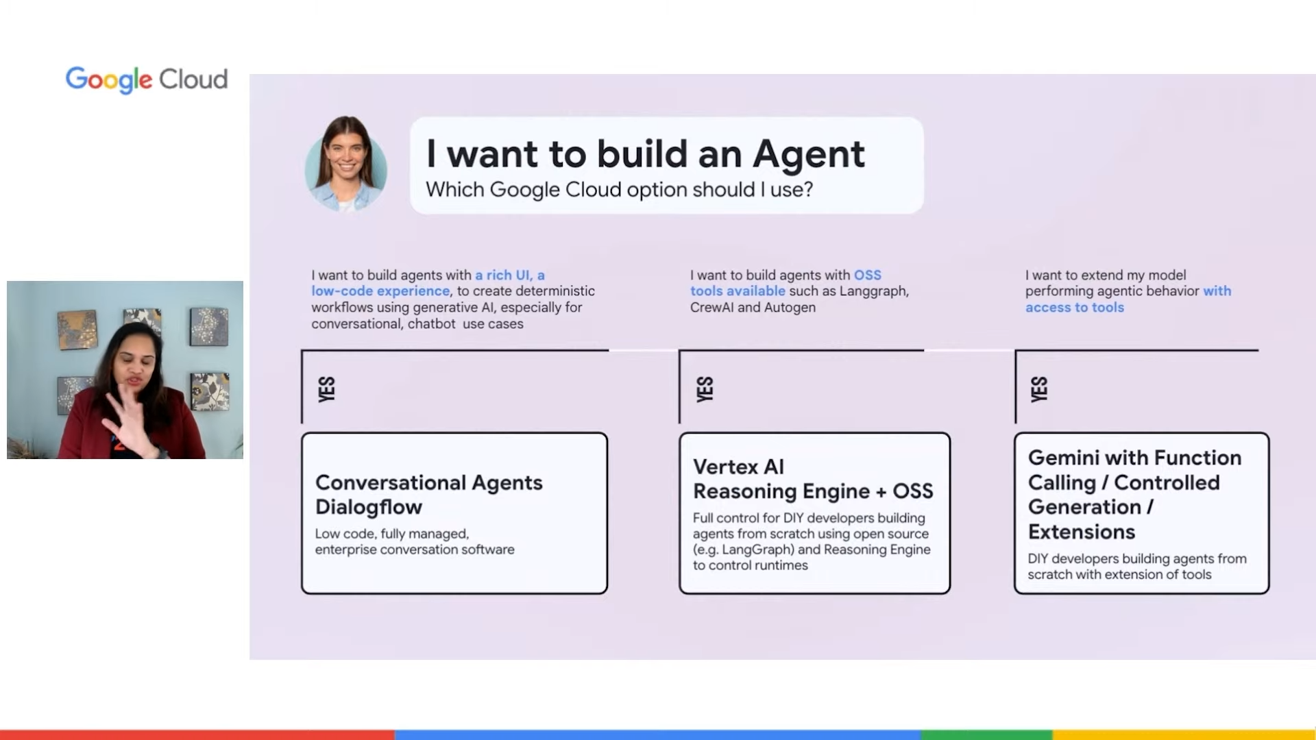
building an agent:
creating prototype ai agent: link

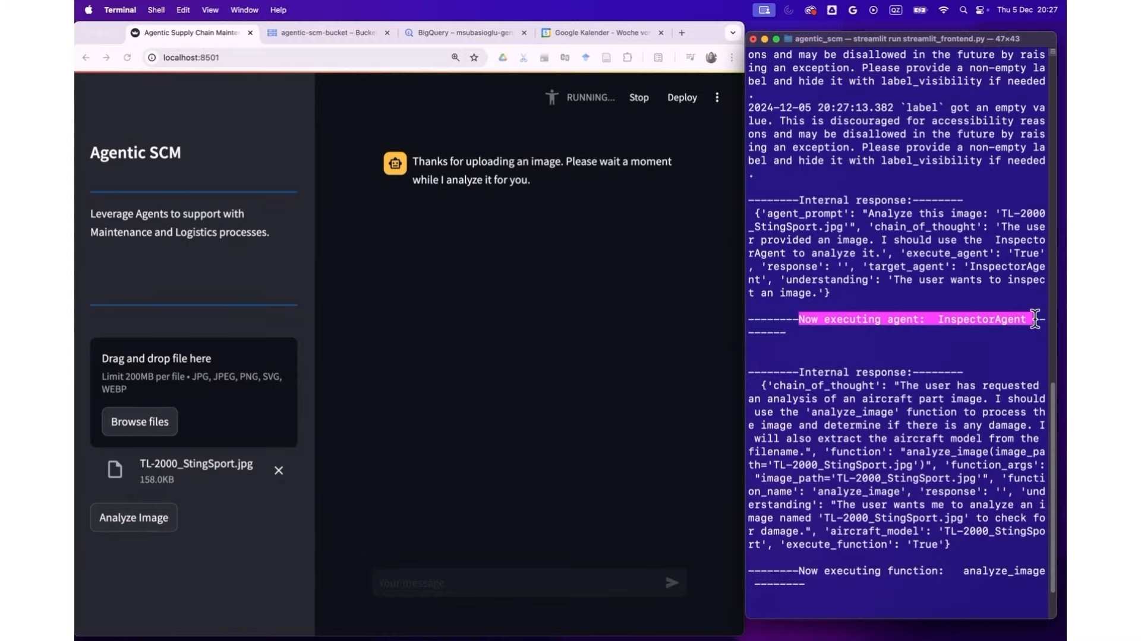
single agent and multi agent
cot

experimentation and evaluation:

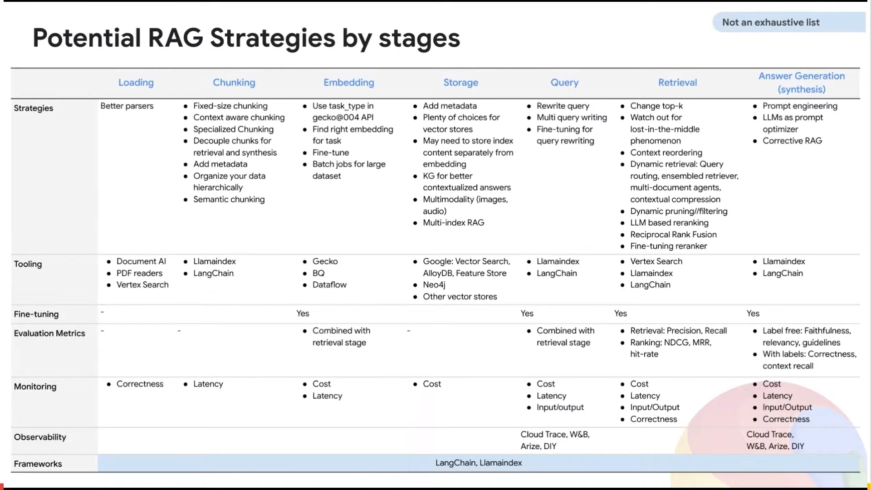
rag
strategies

courses and link → google intermediate courses
link1
link2
link3

intro to genai and gemini – vertex and google cloud link


